Sitecore SEO Analyzer App

**How to run:**

Note: this project is not hosting ready.

1. Open solution (.sln) in the package using visual studio.
2. Clean and restore all dependencies of project.
3. Rebuild project.
4. If success, should be able to run using IIS Express

**How to use:**

1. Input some text to analyze.

Note: application can sanitize more of the unexpected input but might not be able to handle all cases.

1. Input valid url.

Note: application can get all web client content by given url but might not be able to handle all cases related to url or received html content. For this demo purpose let’s use <https://www.sitecore.com/>

1. Select any analysis option(s).

1. Click Analyze.

Note: While application processing the user request the Analyze button will be disabled.

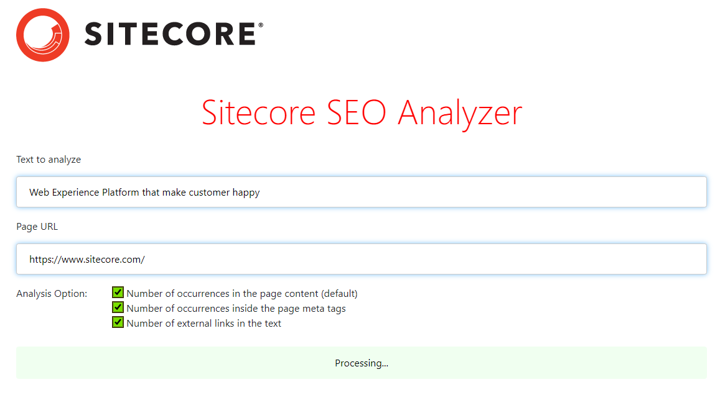

1. Result then populated.

1. Try other keywords and option.

1. User can also sort the table by clicking either table column.